Supplementary Data. Production of small peptides and low molecular weight amino acids by subcritical water from fish meal: effect of pressurization agent

P. Barea, R. Melgosa, A.E. Illera, P. Alonso-Riaño, E. Díaz de Cerio, O. Benito-Román, Sagrario Beltrán, M. Teresa Sanz
Department of Biotechnology and Food Science. University of Burgos. Plaza Misael Bañuelos s/n. 09001 Burgos. Spain. Tel.: +34 947 258810. Fax: + 34 947 258831. E-mail: tersanz@ubu.es

Table S1 Initial rate of release of amino groups, meq leucine/L min, in subW at different temperatures in different atmospheres, N₂ and CO₂.
Temperature, ºC | N₂ | CO₂
140 | 0.0107 ± 0.0006^{a, A} | 0.0136 ± 0.0006^{a,B}
160 | 0.0345 ± 0.0007^{b, A} | 0.040± 0.002^{b, B}
180 | 0.055 ± 0.002^{c,A} | 0.051 ± 0.003^{c, A}
Different lowercase letters in each column indicate that there are statistically significant differences among the slopes at the 99% of higher confidence level for the different pressurization agents at the different temperatures.
Different capital letters in each row indicate that there are statistically significant differences among the slopes at the 99% of higher confidence level at each temperature level considering the effect of the pressurization agent.

Figure S1. Response of different standard proteins and peptides at the same concentration (0.2 mg/mL) by the Lowry assay method

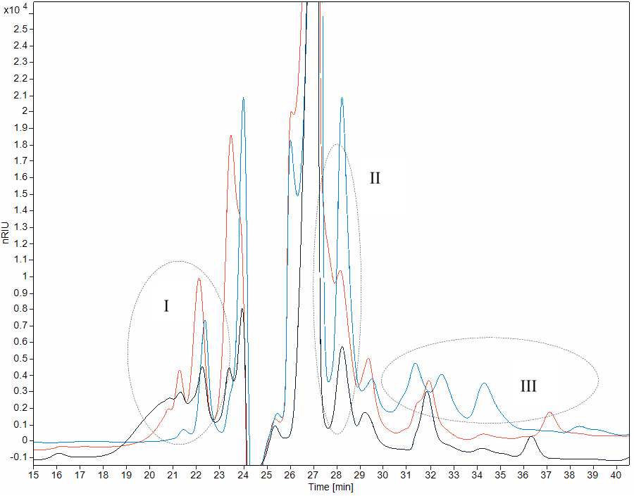

Figure S2. Molecular weight distribution of WSP extract (black), subW hydrolysate in CO₂ at 180 ºC (blue), and enzymatic hydrolysate by Alcalase® (orange).

Corresponding author

